Paper Template for the 8th Typography Meeting Proceedings:

Title of the paper
First author name ¹; Second author(s) name(s)²
¹ First author e-mail; ² Second author(s) e-mail(s)
¹ Institution of the first author; ²I Institution of the second author(s);

Abstract
This document serves as an example and template for the final full papers of the 8th Typography Meeting proceedings.
The abstract presents a synthesis of the work presented, highlighting only the most important parts and most innovating aspects. It should be short, up to a maximum of 500 words. It should start by presenting the aims and goals of the work and the research context or problem. It should proceed by identifying adopted research design and its methodologies (instruments, techniques and application). And then summarize the main results, findings, its implications or applications, conclusions and most relevant contributions. Acronyms and abbreviations should be avoided in the abstract, as well as references to tables, figures or formulas, and even references to other authors.
If the original language of the paper is not in English, authors may opt to write the abstract in their original language first (current section). The title must be translated accordingly (e.g. Resumen, Résumé). And then include the abstract in English (following section).
The abstract must be formatted with “Normal” style. It consists in the application of the font Times (Mac), or Times New Roman (Windows), 12 pt., black, with the line spacing (leading) +1.5 lines and spaced one additional line at the end of the paragraph. Additional paragraphs must not be included to break, or “wrap” the text.
For a more complete description, please check the extended abstract template available online in the conference website.

Abstract
If the original language of the paper is not in English, authors may opt to write the abstract in their original language first (previous section). And then include the abstract in English (current section). Must be formatted with the style “Normal”+ Italic.

Keywords
Up to a maximum of 5 words, separated by commas. Must be formatted with the style “Normal”+ Italic.

Introduction
This document serves as a template for the structure and the application of the text styles for the papers of the 8th Typography Meeting proceedings.
This template is organized in the required structure (Abstract, Keywords, Introduction, Content Sections, Conclusion, References), with the necessary examples and formatting descriptions. A summary of the basic formatting is provided in the end of each section.
The Introduction must be formatted with “Normal” style. It consists in the application of the font Times (Mac), or Times New Roman (Windows), 12 pt., black, with the line spacing (leading) +1.5 lines and spaced one additional line at the end of the paragraph. Additional paragraphs must not be included to break, or “wrap” the text.

Content Sections
In order to maintain the coherence of the proceedings, the papers must include the following sections: Abstract, Keywords, Introduction, Conclusion and References. Authors are free to include any number, title and contents on each section between the Introduction and the Conclusion.
Authors may provide an Abstract in their native language first. Followed by the mandatory English version.
The Introduction section must present a panoramic view of theme in research (Correia & Mesquita, 2013, p. 13), but in addition, it should provide a summarized conceptual framework. It may include: a rationalization of the importance of the research topic, the contribution to the thematic line or discipline addressed; a brief discussion of the methodology (methods, techniques and instruments) without going into much detail; the proposition, research questions, or hypothesis.
The Conclusion section has the purpose to present the discussion of the paper as a whole, synthesizing the main results and findings. It should highlight their importance, their implications, applications and limitations. It concentrate on presenting the final conclusions, emphasizing the most relevant contributions of the paper, their scope within the thematic area, as well as to present recommendations for future, or further development. The Conclusion should be brief, concise and written in a convincing and affirmative tone.
The rest of the sections (the number of sections, titles, and content presented between the Introduction and Conclusion) are the responsibility of each author. We recommend using a familiar structure to this kind of work, such as (for example): Theoretical Background, State of the Art, or Literature Review; Research Methodology; and Results.
The Content Sections must be formatted with “Normal” style. It consists in the application of the font Times (Mac), or Times New Roman (Windows), 12 pt., black, with the line spacing (leading) +1.5 lines and spaced one additional line at the end of the paragraph. Additional paragraphs must not be included to break, or “wrap” the text.

Text Styles and Formatting
In order to simplify the process of editing and revision of the final proceedings, authors should stick to the available paper structure and text formatting (styles and appearance). We also recommend maintaining the page numbers in order to facilitate the revision process.
In this section we describe the main functions and attributes of the style available in this template. The final part of this section presents a table summarizing all of them (Summary of formatting and text styles).

Headings 1, 2 and 3 (Paper Structure and Sections)
Authors must use the template’s available styles (Headings 1, 2 and 3) to structure the document.
“Heading 1” style is reserved for the title of the paper. It consists in the application of the font Times (Mac), or Times New Roman (Windows), 24 pt., black, with the line spacing (leading) +1.5 lines and spaced one additional line at the end of the paragraph.
“Heading 2” style allows to structure the logical sections of the paper, such as the Introduction, the Theoretical Background, Literature Review or Framework, Methodology, Results, Findings and Discussion, Conclusion or the References. It consists in the application of the font Times (Mac), or Times New Roman (Windows), 18 pt., black, with the line spacing (leading) +1.5 lines and spaced one additional line at the end of the paragraph.
“Heading 3” style allows to split each section into units of greater detail. It consists in the application of the font Times (Mac), or Times New Roman (Windows), Bold 12 pt., black, with the line spacing (leading) +1.5 lines and spaced one additional line at the end of the paragraph.

Headings 5 (authors’ names)
“Heading 5” style allows to identify the papers’ authors in order to automatically create the necessary indexes, and to avoid errors from manual editing. It consists in the application of the font Times (Mac), or Times New Roman (Windows), Bold 12 pt., black, with the line spacing (leading) +1.5 lines and spaced one additional line at the end of the paragraph.

Normal (Body text)
The main body of each section contents must be formatted with “Normal” style. It consists in the application of the font Times (Mac), or Times New Roman (Windows), 12 pt., black, with the line spacing (leading) +1.5 lines and spaced one additional line at the end of the paragraph. Additional paragraphs must not be included to break, or “wrap” the text.

Images (Figures) and Graphics
Images and graphics must be included in the document and present a minimum resolution for printing and reading. For example, 300 DPI at a 100% scale, or 72 DPI at a 25% scale in line with text (Figure 1). Authors must reference the figures appropriately in the body of the text, and present them after the reference. Figures and graphics must include descriptive captions. When retrieved, or adapted from another source, authors must include the reference to the original source.
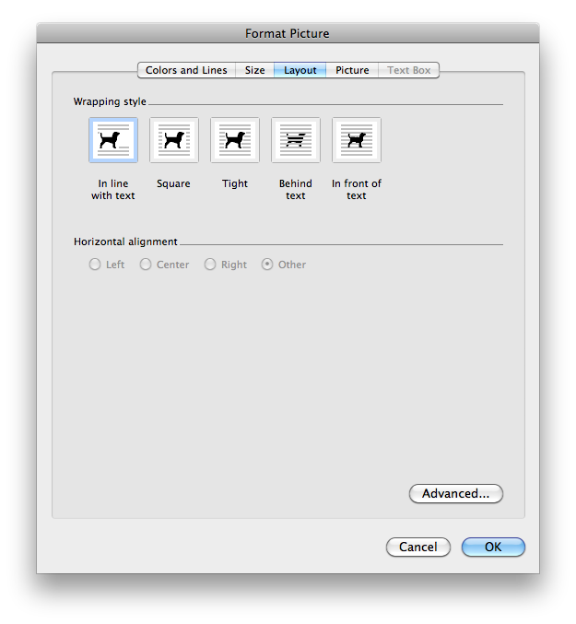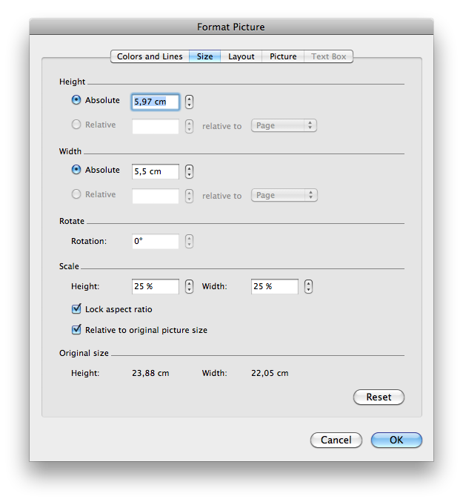
Figure 1 – Figures and Graphics formatting, resolution and scaling options.

Tables
Tables should also have a simple style consistent with the rest of the document, according to the APA Style recommendations (Figure 2).
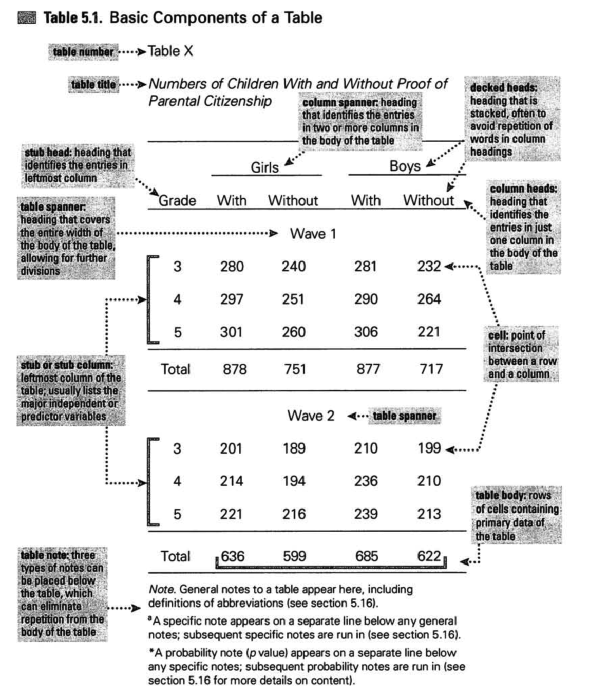
Figure 2 – Table formatting options, according to APA (source: APA, 2010, p. 129)
Its formatting consists on the inclusion of the first line as a table header, in bold, without background color. With a top and bottom line of ½ pt., in solid black stroke.
Tables can be quickly formatted with the style “Light Shading”, and by deactivating the option “Banded Rows”, available in the Ribbon’s table formatting options (Figure 3).
Figure 3 – "Light Shading" table formatting options
Tables and their contents must be formatted with the style “Normal” with the font size of 8 pt.. Table formatting must have all internal spacing set to 0,1 cm (0,5’’) (Figure 4).
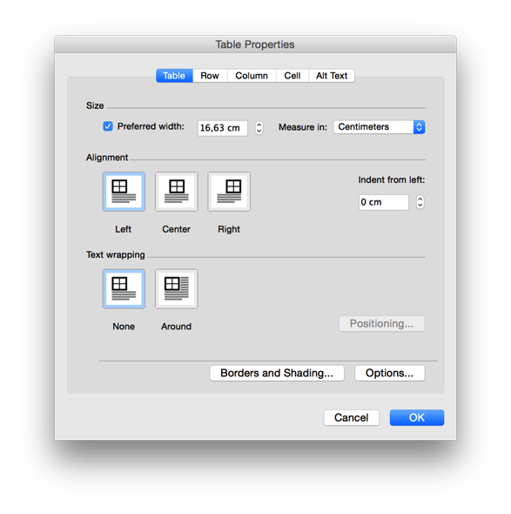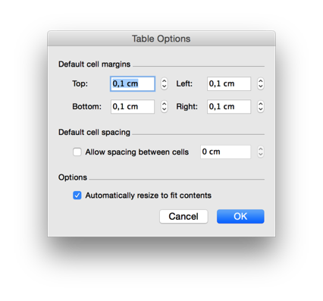
Figure 4 – Table spacing formatting options available in: Table Properties: Options

Captions and information (numbering and footnotes)
The captions of images (figures), graphics and tables, as well as the remaining information elements, such as footers and page numbering must have a similar formatting. It consists in the application of the appropriate style “Caption”, “Footnote” and “Page Number”.
Captions use Times New Roman, Bold, 8 pt., black, with the spacing between rows +1.5 lines. They use a spacing of one line before and at the end of paragraphs.
Captions of figures must appear after the image. Captions (or titles) of tables must appear before the table.
Footers, numbering and other elements of metadata using Times (Mac) or Times New Roman (Windows), normal, 8 pt., black, with the spacing between rows +1.5 lines, with no additional paragraph spacing.

Citations and block quotations
Citations or quotations must be done using the author-date format, according to the last edition of the APA style (APA, 2010). After the quoted text (within quotation marks), the following elements must be presented in order: 1) authors’ last name, followed by a comma; and 2) year of publication of the document; and, if it is a direct quote, 3) the page number(s). This information must be included within curved parenthesis ( author, date, page number).
Quotations must be formatted in the style of the text in which they are included: “Normal” if within the body of the text; “Caption” if included within captions of figures, graphics or tables, as well as other textual elements.
Common formats of direct (in-line) quotations are short (under 40 words) and long (over 40 words). When more than 40 words are literally used, the quotation must be formatted as a long block quotation with the “Quote” text style. It is identical to the “Normal” style, indenting the left margin of the text in 1,27 cm (0,5’’), and applying a double space to leading. The quotation must not be included within quotation marks. The reference to the author and date must provided in the end, followed by a comma and the page (p.), or the range of pages (pp.) within curved parenthesis, following the final period:
If the quotation comprises 40 or more words, display it in a freestanding block of text and omit the quotation marks. Start such a block quotation on a new line and indent the block about a half-inch from the left margin (in the same position as a new paragraph). If there are additional paragraphs within the quotation, indent the first line of each an additional half inch. Double-space the entire quotation. At the end of a block quotation, cite the quoted source and the page or paragraph number in parentheses after the final punctuation mark. (APA, 2010, p. 171)

Summary of formatting and text styles
Table 1 – Summary of formatting styles
Name | Purpose | Description of the formatting styles
Heading 1 | Title of the paper | Times New Roman, bold, 24 pt., +1,5 leading, +2 lines before and +1 line after
Heading 2 | Split the logical parts of your communication | Times New Roman, bold, 18 pt., +1,5 leading, +2 lines before and +1 line after
Heading 3 | Split the logical parts of each section | Times New Roman, bold, 12 pt., +1,5 leading, +2 lines before and +1 line after
Heading 5 | Authors’ names | Times New Roman, bold, 12 pt., +1,5 leading, +2 lines before and +1 line after
Normal | Body text | Times New Roman, 12 pt., +1,5 leading, +1 line after
Images | Formatting images | 300 DPI @100%, or 72 DPI @ 25% scale
Table | Formatting tables and their contents | Adapted “Light Shading” table style. Bold header row. ½ pt. solid black, upper and lower horizontal border strokes. No vertical borders . Cell spacing of 0,1 cm (0,5’’) in all directions. Top left alignment.  Text in Times New Roman, normal, 8 pt., simple leading, no spacing before or after.
Caption | Captions of images (figures), graphics and tables | Times New Roman, 8 pt., +1,5 leading, +1 line before and after
Footnote Text | Footnotes | Times New Roman, 8 pt., +1,5 leading, no spacing before or after.
Page Number | Page numbering | Times New Roman, 8 pt., +1,5 leading, no spacing before or after.
Short Quotation | Normal | Quoted text within quotation marks, in the style of the current text . Reference in the author-date format, within parenthesis, including page (p.)
Long or Block Quotation | Quote | Quoted text Times New Roman, 12 pt., left indent 1,27 cm (0,5’’), double spacing, without quotation marks. Reference in the end in the author-date format, after the final period, within parenthesis, including page (p.) or page interval (pp.)

Conclusion
In this template we present a example for the necessary structure and formatting for the papers to publish in the 8th Typography Meeting proceedings. We hope the examples and styles demonstrated here are enough for the authors to format and submit their final papers accordingly. In case of inquiry, please contact the secretariat through the email: et-8@ualg.pt

References
References should use the 6th edition of the APA standards for the body text and final bibliographic references section. The APA standards can be reviewed online at: http://www.apastyle.org.
APA. (2010). Publication Manual of the American Psychological Association (6th Revise). Washington: American Psychological Association;
Correia, A. M. R., & Mesquita, A. (2013). Mestrados e Doutoramentos. Porto: Vida Económica.

Abstract template available online at: http://et-8.ualg.pt/ (retrieved on 2017-04-15).

